1. Set Up and Create a Git Repository

This section will guide you to:

* Download Git from the official site and configure it
* Generate files, initialize .git directory, and commit the files

This guide four has subsections, namely:

* + 1. Downloading Git from the official site for your operating system
    2. Configuring Git in your system
    3. Generating files and initializing the .git directory
    4. Executing the basic commands

**Step 1.1.1:** Downloading Git from the official site for your operating system.

Open your Chrome browser and navigate to <https://git-scm.com/downloads> page of Git. Click on the **Download <Version_Number> for Windows** button available on the right side of the screen as shown in the screenshot below:

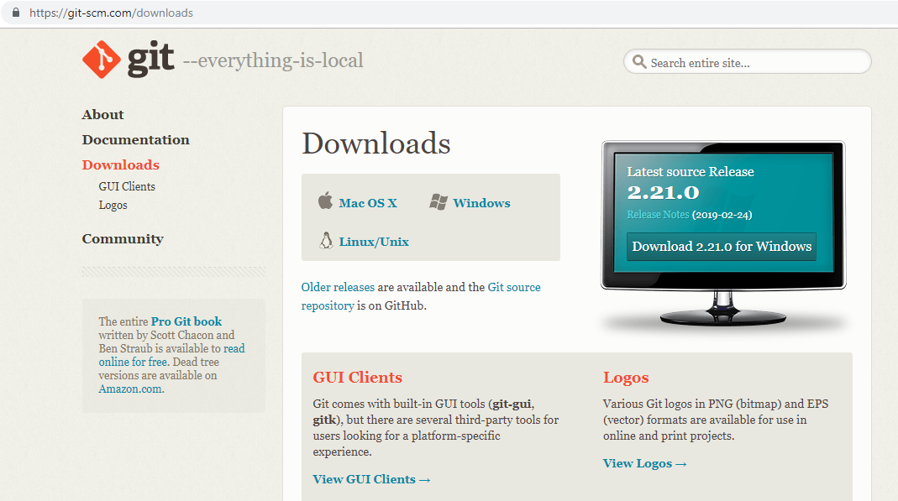

**Step 1.1.2:** Configuring Git in your system.

* Locate the downloaded git.exe file
* [right-click] on the executable git file and select **Run as administrator**
* Once you accept the installation request, you will be directed to the **Information** window. Click on **[Next >]** button.
* Do not make any changes and click on **[Next >]** button.
* You will be prompted to select the default editor used by Git. Select **Use Vim (the ubiquitous text editor) as Git’s default editor** and click on **[Next >]** button.
* You will be prompted to select how to use Git. Select **Git from the command line and also from third-party software** and click on **[Next >]** button.
* You will be prompted to select the HTTPS transport backend. Select **Use the OpenSSL library** and click on **[Next >]** button.
* You will be prompted to select a style to treat the line endings in text files. Read the options and select one per your preference. Click on **[Next >]** button.
* You will be prompted to select the terminal emulator. Read the options and select as per your preference. Click on **[Next >]** button.
* You will be prompted to choose the features to enable. Do not make any changes and click on **[Install]** button.

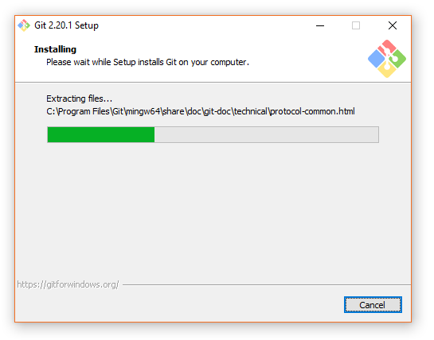

**Step 1.1.3:** Generating files and initializing the .git directory.

* Create a folder on your desktop and open it.
* Create the files: hello.js, index.html, and helloWorld.java.
* Open the Git terminal and navigate to the folder you have created.
* Execute the following command to initialize the .git repository:

git init

**Step 1.1.4:** Executing the basic commands.

* Add all the files to your git repository using the following command:

*git add*

* Commit the changes using the following command:

*git commit -m*

2 CRUD Operations in Git

1. Creating

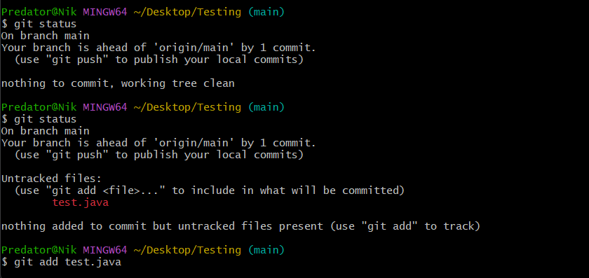

Commands used

git status

git add <filename>

git commit -m “Message”

1. Read

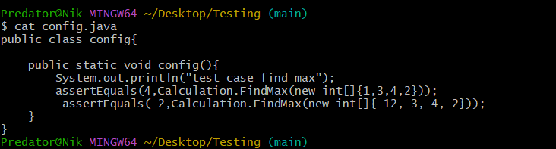

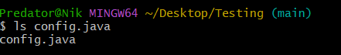

Commands used

cat <filename>

ls <filename>

1. Update

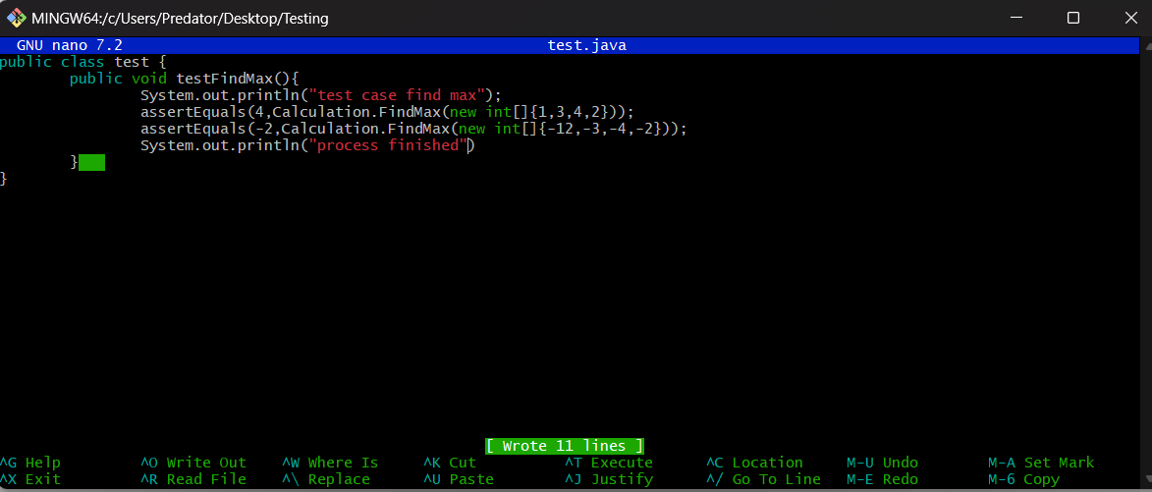

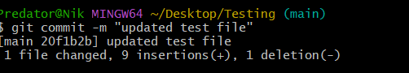

Commands used

nano <filename>

(do all the changes then use ctrl+ o to write out and ctrl + x to exit)

Git commit -m “Message”

1. Delete



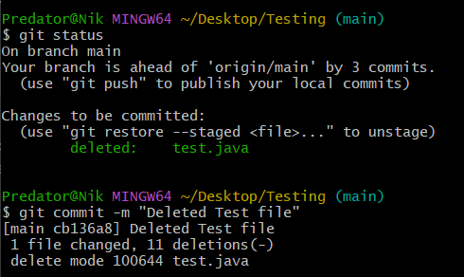

Commands used

rm <filename>

git status

git commit -m “Message”

3 Set Up and Configure GitHub Account

This section will guide you to:

* Create your GitHub account
* Connect from local Git repository to remote GitHub via SSH
* Initiate the first push

This guide has four subsections, namely:

1.3.1 Setting up your GitHub account

1.3.2 Creating SSH-key and adding it to GitHub

1.3.3 Logging at local Git to connect with remote GitHub

1.3.4 Creating a repository in your GitHub account

**Step 1.3.1:** Setting up your GitHub account.

Navigate to https://github.com/ and click on **Sign up for GitHub**. Enter the details and click on **Create an account**.

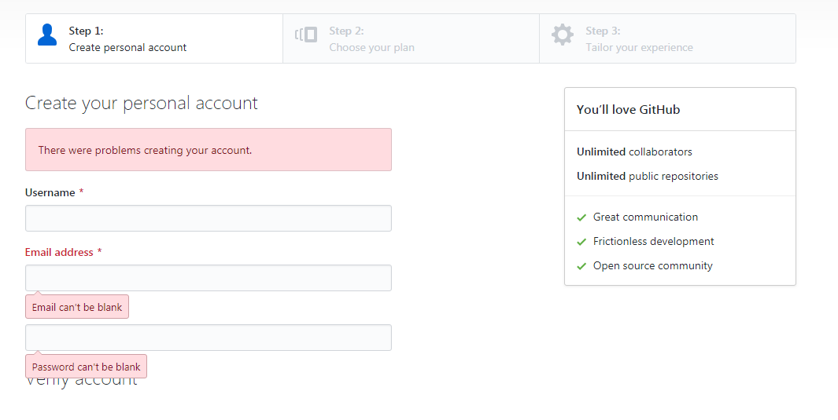

Once you’re at **Step 2: Choose your personal plan**, Select **Free,** and click on **Continue**. You can share basic information about yourself or you can select **skip this step**.

You must have received an email to confirm your account. It is important to confirm your account before you use GitHub. Once you have confirmed, you are successfully signed for GitHub.

**Step 1.3.2:** Creating an SSH Key and adding it to GitHub.

You can create ssh-key via **Git bash** by following the steps:

* Open your **Git bash**
* Execute the command:

***ssh-keygen -t rsa -b 4096 -C “<your email address>” 🡪 press [enter]***

* Do not enter anything but [enter] until the setup is complete
* Start the ssh-agent in the background:

eval $(ssh-agent -s)

* Add your SSH private key to the ssh-agent

ssh-add ~/.ssh/id_rsa

* Copy the SSH key to your clipboard

clip < ~/.ssh/id_rsa.pub

* Copy the entire key from the clipboard. Choose ***Your avatar* > settings** > **SSH & GPG Keys** and click on **New SSH** **key** and paste the key and **save** it

**Step 1.3.3:** Logging at local Git to connect with remote GitHub.

Open the Git terminal and execute the commands below by replacing **your_Email_Id** with your registered email address with GitHub and replace **Your_Username** with your GitHub username.

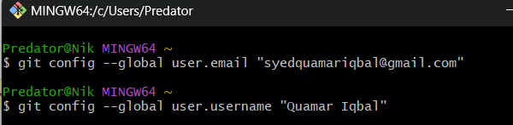

**Step 1.3.4:** Creating a repository in your GitHub account.

Go to the homepage of GitHub.com and click on **New Repository** as shown below:

